Module 1– Week 1

1. Variables of Interest
The key variables analyzed include:
• lung_capacity (numeric): Measured lung capacity in liters (L)
• age (integer): Subject’s age in years
• height_in (numeric): Subject’s height in inches
• smoker (factor: “Smoker” / “Non‑smoker”): Tobacco use status
• gender (factor: “Male” / “Female”): Subject’s self‑reported gender
• c_section (factor: “Yes” / “No”): Whether the individual was born via caesarean section

2. Data Cleaning Performed
Categorical variables were explicitly converted into factors. No missing values were observed. The 'Smoke', 'Gender', and 'Caesarean' variables were converted to categorical types for proper analysis. Numeric variables were retained as-is for summary statistics and histogram generation.
Steps taken:
1. Renaming: Standardized column names (e.g., `LungCap` → `lung_capacity`)
2. Missing values: Removed rows with NA in any of lung_capacity, age, or gender
3. Whitespace & case: Trimmed leading/trailing spaces and converted all text to lowercase for smoker, gender, and c_section
4. Re‑coding: Converted yes/no strings to factor levels
5. Type conversion: age → integer; height_in, lung_capacity → numeric
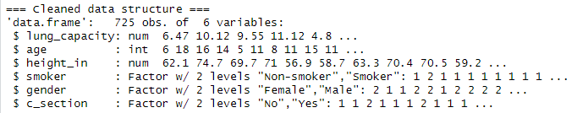

3. Steps in Initial Analysis
The dataset was explored through frequency tables, cross-tabulations, and histograms. Bar plots were used for categorical comparisons, and histograms illustrated the distribution of numeric variables.
1. Frequency Distributions: Gender and smoker status
2. Cross‑Tabulation: Smoker × Gender using flat table and SPSS-style CrossTable
3. Base-R Histograms: Lung capacity and age distributions
4. ggplot2 Visualizations: Faceted and overlay histograms, boxplots
5. Scatter Plot (plotly): Lung capacity vs. height colored by smoker
6. Boxplots: Lung capacity across gender and smoker status

4. Results
Lung capacity varied across the population, with a slight skew toward higher values. Smoking was less common among the individuals, and gender was almost equally split. Caesarean births were more frequent among females. Cross-tabulations showed a slight difference in smoking patterns across genders.
• Gender distribution: Roughly balanced Male vs. Female
• Smoker status: % smokers vs. % non-smokers
• Smoker × Gender: More smokers among males
• Lung capacity: Normal with slight skew; smokers lower on average
• Age: Smokers concentrated in mid-teens; non-smokers skew younger
• Height vs. LungCap: Positive correlation
• Boxplots: Lower median lung capacity in females and smokers

5. Charts, Tables and Graphs Created

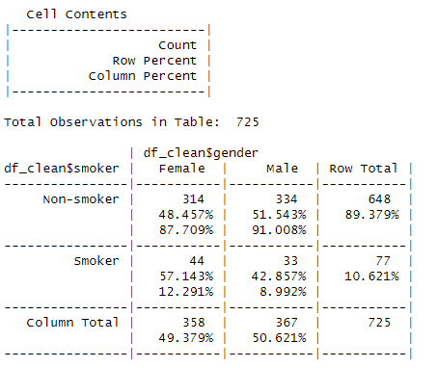

Tables:
Table No. | Description | File
1 | Frequency of Gender | freq_gender
2 | Frequency of Smoker Status | freq_smoker
3 | Crosstab: Smoker vs. Gender | ftable_smoke_gender

Figure No. | Description | File/Code
1 | Histogram of Lung Capacity | hist(...)
2 | Age Distribution by Smoker Status | ggplot(p_age)
3 | Lung Capacity by Smoker Status | ggplot(p_lc)
4 | Scatter: Lung Capacity vs. Height (interactive) | ggplotly(p_int)
5 | Boxplot: Lung Capacity by Gender & Smoker Status | ggplot(p_box)

